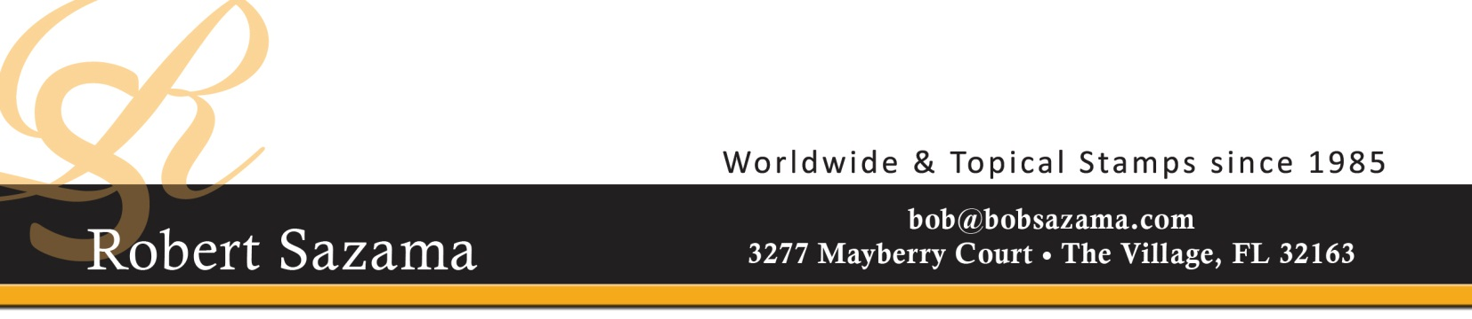
Robert M. Sazama
Collector since the 1950s
Dealing in stamps since 1985
Philatelic Appraiser
Auction Agent
Professional Memberships
American Stamp Dealers Association
National Stamp Dealers Association (Vice President & member of the Board of Directors)
Canadian Stamp Dealers Association
International Federation of Stamp Dealers (contributing writer for NSDA)
American Philatelic Society (As a dealer member I provide free advisory services to assist surviving spouses in the disposal of stamp collections)
Florida Stamp Dealers Association (treasurer)
American Topical Association (past advertising manager & presently on the ethics committee for the ATA sales site)
Japanese Philatelic Society – past dealer membership
China Stamp Society
Past & present memberships in the following local stamp clubs: Springfield & Carbondale, IL; Topeka, KS; Nashville, TN; and Orlando,
Ocala, Hernando, The Villages, and Hollywood FL
Experience:
A professional dealer since 1985 with appraisal activities since 1995
Clients have included Bank Trust Departments, lawyers and individuals
All appraisals are completed on the basis of “Fair Market Value.” When requested summary letters are written outlining the contents of the
appraisal and the basis for evaluation.

Fees:
Legal and insurance appraisals requiring detailed typed summaries are $100/hour plus travel expenses.
Collections and accumulations requiring only a basic idea of value $75/hour or fee waived if evaluation does not merit a fee.
Over the phone consults to determine if collection is appraisable are free.

It is also a policy of our appraisal service not to remove the collection from the appraisal location and a person of your designation must be
present during the evaluation.

